**FUNDAMENTALS OF REINFORCEMENT LEARNING**

**Nguyễn Hoàng Việt – QE170216**

**AI17C**

**REL301m**

1. **Certificate**

Link: <https://coursera.org/share/73396331c233a267e3180ed125f22b9f>

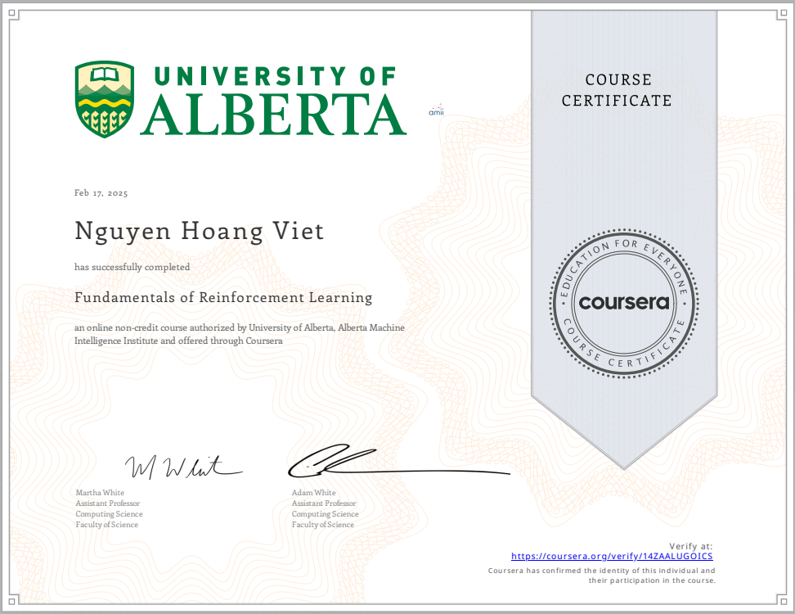

1. **Assignment**

* **Bandits and Exploration/Exploiration**: [link github](https://github.com/nguyen-hoang-viet/reinforcement-learning-course/blob/main/assignment/course%201/Bandits_and_Exploration_or_Exploitation.ipynb)
* **Optimal Policies with Dynamic Programming:** [link github](https://github.com/nguyen-hoang-viet/reinforcement-learning-course/blob/main/assignment/course%201/Optimal_Policies_with_Dynamic_Programming.ipynb)

1. **Quiz**

* Sequential Decision-Making

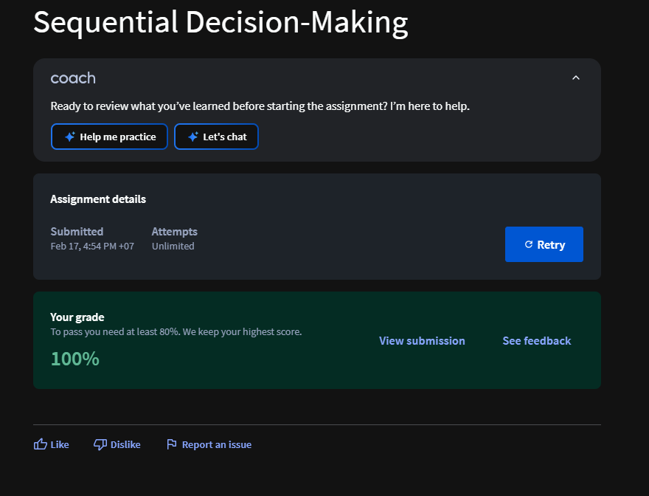

* MDPs

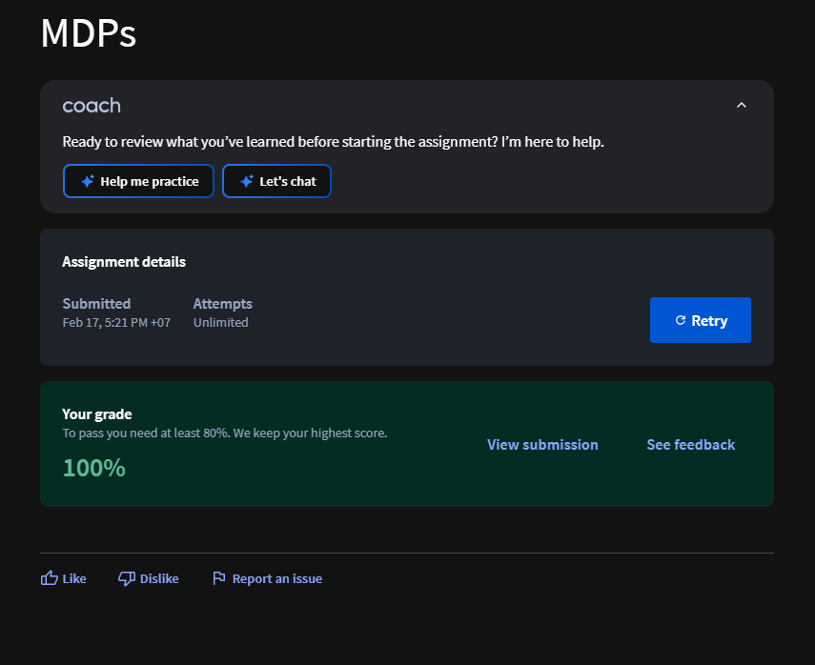

* Value Functions and Bellman Equations

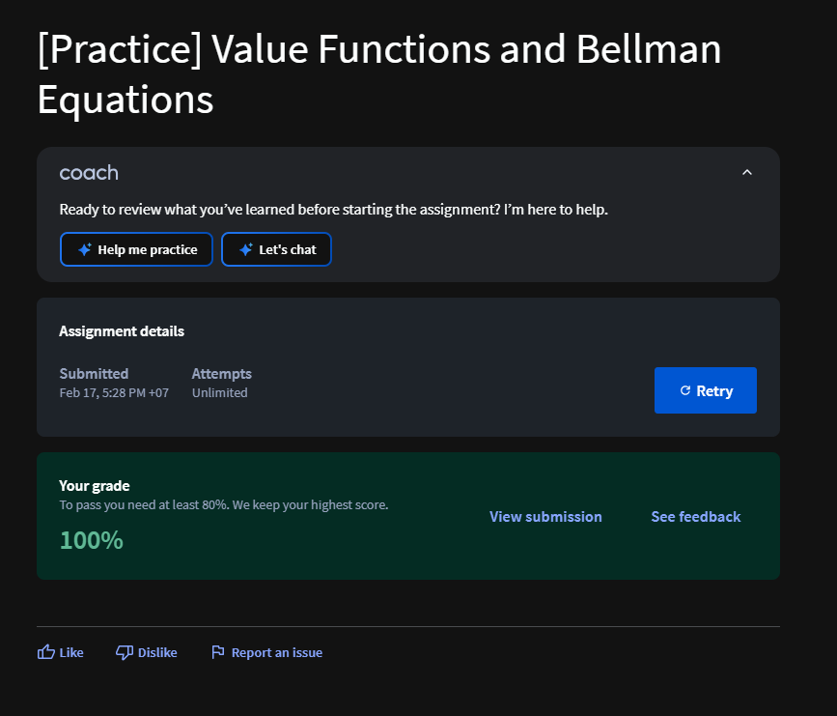

* Value Functions and Bellman Equations

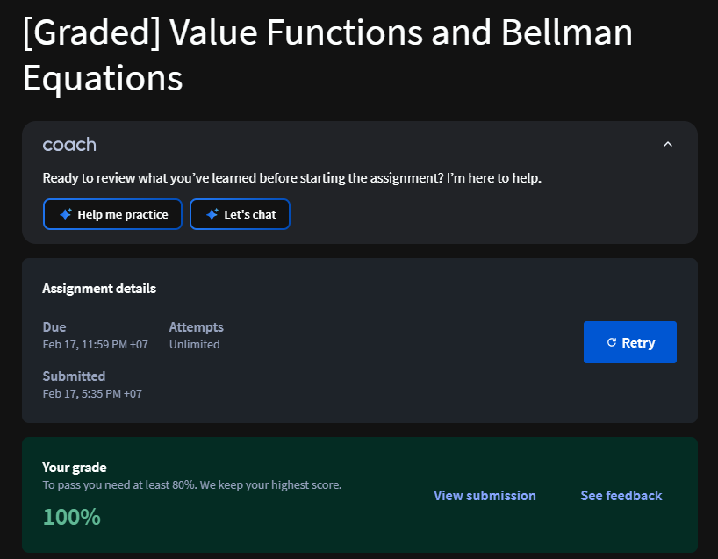

* Dynamic programming

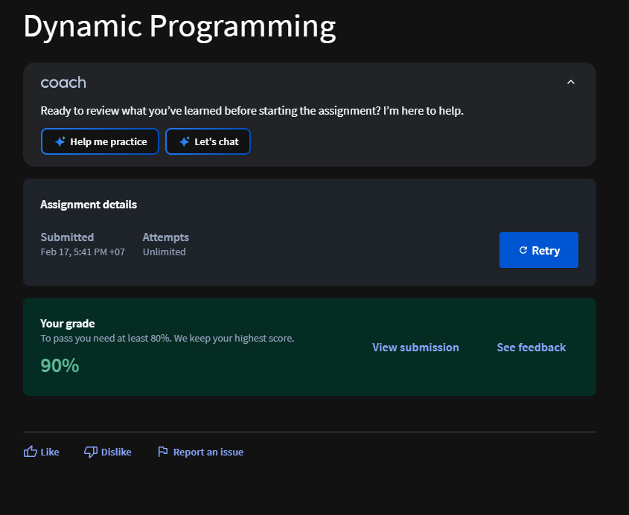

* Total

